What is JavaScript DOM?

The Document Object Model is a cross-platform and language-independent interface that treats an XML or HTML document as a tree structure wherein each node is an object representing a part of the document. The DOM represents a document with a logical tree.
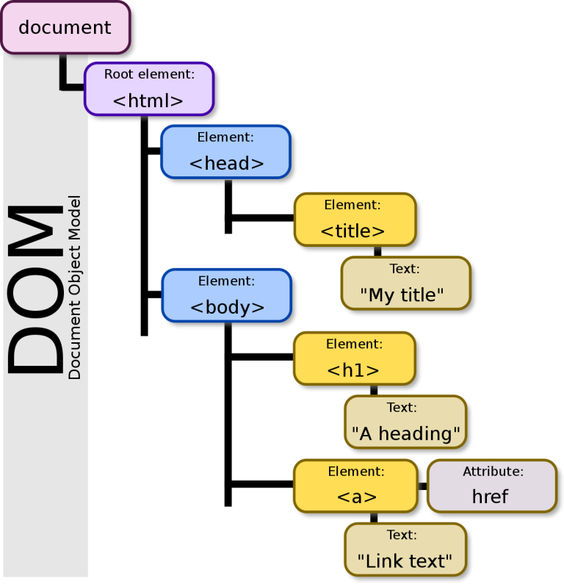
The HTML DOM permit JavaScript (or other scripting languages) to interact with the elements of an HTML document in a dynamic way. It propose a set of objects, properties, and methods that can be used to access, modify, add, or delete HTML elements, attributes, and text content.
Some of the key purposes of HTML DOM are:
- Manipulating HTML elements
- Event handling
- Dynamic content generation
- Traversing the document

Example 1:
<!DOCTYPE html>
<html>
<head>
<title>DOM Example</title>
<script>
// Function to change the text color of a paragraph
function changeTextColor() {
var paragraph = document.getElementById("myParagraph");
paragraph.style.color = "blue";
}
// Function to hide an image
function hideImage() {
var image = document.getElementById("myImage");
image.style.display = "none";
}
</script>
</head>
<body>
<h1>DOM Example (DOM manipulation in action)</h1>
<p id="myParagraph">This is a paragraph.</p>
<img id="myImage" src="example.jpg" alt="Example Image">
<button onclick="changeTextColor()">Change Text Color</button>
<button onclick="hideImage()">Hide Image</button>
</body>
</html>

Example 2:
<!DOCTYPE html>
<html>
<head>
<title>CSS Example</title>
<meta charset="UTF-8">
<meta name="viewport" content="width=device-width, initial-scale=1.0">
</head>
<body>
<h1>JavaScript DOM</h1>

<p>This example uses the addEventListener() method to attach a click event to a button.</p>

<button id="myBtn">Try it</button>

<script>
document.getElementById("myBtn").addEventListener("click", function () {
alert("Hello World!");
});
</script>
</body>
</html>

EventTarget.addEventListener():

The EventTarget method addEventListener() sets up a function that will be called whenever the specified event is delivered to the target.

addEventListener() works by adding a function or an object that implements EventListener to the list of event listeners for the specified event type on the EventTarget on which it's called.

Example 3:
<!DOCTYPE html>
<html>
<head>
<title>CSS Example</title>
<meta charset="UTF-8">
<meta name="viewport" content="width=device-width, initial-scale=1.0">
</head>
<body>
<h1>JavaScript DOM</h1>

<p>This example uses the addEventListener() method to add many events on the same button.</p>

<button id="myBtn">Try it</button>
<p id="demo"></p>
<script>
var x = document.getElementById("myBtn");
x.addEventListener("mouseover", myFunction);
x.addEventListener("click", mySecondFunction);
x.addEventListener("mouseout", myThirdFunction);

function myFunction() {
document.getElementById("demo").innerHTML += "Moused over!<br>";
}

function mySecondFunction() {
document.getElementById("demo").innerHTML += "Clicked!<br>";
}

function myThirdFunction() {
document.getElementById("demo").innerHTML += "Moused out!<br>";
}
</script>
</body>
</html>

Example 4:
<!DOCTYPE html>
<html lang="en">
<head>
<meta charset="UTF-8">
<meta http-equiv="X-UA-Compatible" content="IE=edge">
<meta name="viewport" content="width=device-width, initial-scale=1.0">
<title>Document</title>
</head>
<body>
<h2>JavaScript HTML DOM Create Element</h2>
<div id="div1">
<p id="p1">The Starting Paragraph</p>
<p id="p2">The Middle Paragraph</p>
</div>
<script>
const endParagraph = document.createElement("p");
const node = document.createTextNode("The end Paragraph");
endParagraph.appendChild(node);
const element = document.getElementById("div1");
element.appendChild(endParagraph);
</script>
</body>
</html>

Virtual Dom & Shadow DOM

